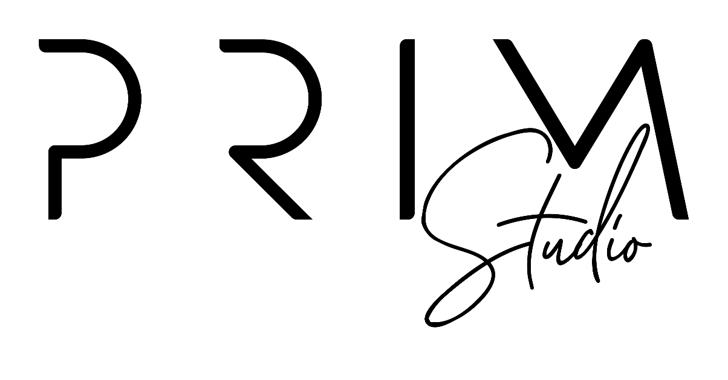
CONTRACTOR & LICENSING TERMS & CONDITIONS

PRIM
PERSONAL

The licensed asset can appear in any non-commercial project

CAN BE USED FOR
- End Products Not For Sale
- Social media account with non-commercial activities

CANNOT BE USED FOR
- End products for sale
- Apps, web apps, or games

PRIM
COMMERCIAL

The licensed asset can appear in any capacity for up to 2 calendar years.

CAN BE USED FOR
- Physical or digital end products for sale
- Personal and business social media account (s) owned and managed by the licensee
- Unlimited physical advertisements for local markets
- Digital paid advertisements with unlimited impressions
- Broadcast and streaming for up to 1 year
CANNOT BE USED FOR
- Exclusivity
PRIM
EXTENDED

The licensed asset can appear the lifetime of the licensee’s business for the purpose intended.

CAN BE USED FOR
- Physical or digital end products for sale
- Unlimited business social media accounts owned and managed by the licensee
- Unlimited physical advertisements for local, national, and global markets
- Digital paid advertisements with unlimited impressions
- Broadcast and streaming for unlimited lifetime viewers
- Exclusivity

Exclusivity:
This term fully explains the overall rights to use ideas, concepts and design deliverables created by Prim & Proper Ink. Prim & Proper Ink will always maintain the right to use any and all designs in portfolio presentations and inside promotional capacities.
Personal Exclusivity License:
Prim & Proper Ink reserves the rights to continue usage of the ideas, concepts and design deliverables created by Prim & Proper Ink in all capacities. Prim & Proper Ink will continue to use the ideas, concepts and design deliverables for commercial use and for means of profit.

Commercial Exclusivity Licensing:
Prim & Proper Ink reserves the rights to continue usage of the ideas, concepts and design deliverables created by Prim & Proper Ink in all capacities. Prim & Proper Ink will continue to use the ideas, concepts and design deliverables for commercial use and for means of profit.
The Licensee is provided with raw files to alter in any way necessary to fit the need of the business entity named in this contract. Please see restrictions in Table Prim 1.1

Extended Commercial Exclusivity Licensing:
Prim & Proper Ink will not continue usage of the concepts and design deliverables created for the commission and purpose of this project. Prim & Proper Ink will not continue to use the design deliverables for commercial use nor for the means of profit. Prim & Proper Ink will not promote nor display the contracted design deliverables publicly without express permission from the licensee for up to 2 years.
The Licensee is provided with raw files to alter in any way necessary to fit the need of the business entity named in this contract.

This License Agreement contains important legal terms, and Licensee acknowledges that by completing the purchase process and/or checking “agree”, Licensee has read the entire License Agreement and agrees to the terms herein, including, without limitation. Prim & Proper Ink - Prim Studio offers different types of license agreements and the one selected at the time of purchase applies to Licensee’s use of the Licensed Asset.
This License Agreement states the terms and conditions of Licensee’s non-exclusive and limited copyright license with respect to the digital content (“Licensed Asset”) made available by primandproperink.com and purchased by Licensee.
The Licensed Asset will be delivered to you by WeTransfer at the account email address Prim & Proper Ink - Prim Studio has on file along with this License Agreement to retain this for your records.
This License Agreement may also apply to digital content that Prim & Proper Ink - Prim Studio makes available at no charge (e.g., for promotional purposes).

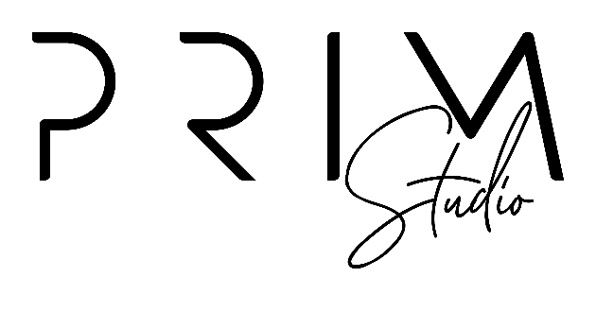
1. PARTIES TO THE LICENSE AGREEMENT
1.1 - This License Agreement is an agreement between:
(a) The “Licensee” who is the individual person or business indicated as the licensee during the purchase process
and
(b) Prim & Proper Ink - Prim Studio Labs, Inc. (“Prim & Proper Ink - Prim Studio”)
1.2 - This is an individual license for Non-commercial use (as defined below) only, and the Licensed Asset may be used and accessed (as permitted in this License Agreement) only by a single individual person/entity, who is the Licensee indicated at the time of purchase.
If multiple individuals will work together to use the same Licensed Asset, then each individual must purchase a license for that Licensed Asset. For use by a business, such as an employer, one of the license agreements that permits Commercial use is required.

2. THIS LICENSE AGREEMENT PERMITS COMMERCIAL USE AND NON-COMMERCIAL - USE DEFINED

2.1 - Commercial Use
“Commercial” use is any use: (i) that involves an exchange of money or other consideration, (ii) that promotes a business (e.g., sole proprietorship, corporation, or partnership), product, or service, or (iii) where financial gain or other consideration is either sought or a result, directly or indirectly, of Licensee’s use of the Licensed Asset. If any one or more of the criteria in (i), (ii), and (iii) is met, then the use is deemed “Commercial”.
2.2 - Non-Commercial Use (Personal)
“Non-commercial” use is a use for solely personal purposes; any use that meets the definition of “Commercial use” cannot be a Non-commercial use.

3. PERMITTED USES AND LIMITATIONS
An “End Use” of a Licensed Asset means use of the Licensed Asset only as expressly permitted below:

3.1 - End Products
- Physical Products for Commercial Use or Non-commercial Use: Licensee may create physical end products such as, but not limited to, clothing, cards, invitations, stickers, mugs, stamps, candles, posters, signs, home decor, etc. for Commercial use or Non-commercial use.
- Product Packaging for Commercial Use of Non-commercial Use: Licensee may create physical or digital end packaging products used for resale or wholesale such as, but not limited to, boxes, labels, stickers, or containers, etc., for Commercial use or Non-commercial use.
- Digital Products for Commercial Use or Non-Commercial Use: Licensee may create digital end products for resale such as static designs, static website elements for Commercial use or Non-commercial use.
- Digital or Print Publication for Commercial Use or Non-commercial Use: Licensee may use the Licensed Asset in digital or print publications such as magazines, cards, invitations, photo albums, and scrap books, e-books or e-publications, for Commercial use or Non-commercial use.

3.2 - Social Media, Marketing, and Advertisements
- Personal Social Media for Non-Commercial Use: If applicable (e.g., for an individual), one (1) personal or individual social media accounts for Non-commercial use.
- Company Social Media for Commercial Use: If applicable (e.g., to a business), all Licensee owned and managed company social media accounts are allowed for Commercial use. No limit on accounts and pages owned and managed by the Licensee for Commercial use.
- Physical (Printed) Advertisements for Commercial Use: Such as billboards, signage, printed advertisement, etc. for Commercial use in Local markets, National markets, and Global markets.
- Digital Advertisements for Commercial Use: Internet advertisements such as advertisements served by Google Ads, Bings Ads, Facebook Ads, LinkedIn Ad, etc. for Commercial use.

* Quantity Limitations on Promotion and Advertisements: No limit on the number of impressions of social media posts or advertisements incorporating the Licensed Asset for Commercial use or Non-commercial use (where Non-commercial use is applicable).

4. PROHIBITED USES (these uses may be available with a custom license, contact Prim & Proper Ink - Prim Studio to find out more):
4.1 - End Products
✗ On-Demand Applications (Such as Print-on-Demand and Create-on-Demand Services). Any use that allows anyone other than the Licensee, such as an end user, to customize a digital or physical end product is prohibited, whether for Commercial use or Non-commercial use. This includes, but is not limited to, “print on demand”, “made to order” or “download on demand” application.
4.2 - Trademark and Copyright
✗ Trademark: Licensed Asset may not be used as part of a trademark, service mark, design mark, trade-name, or similar use. In no event does this License Agreement allow Licensee to -- and Licensee shall not seek to -- register, protect, or enforce any trademark or similar rights in the Licensed Asset itself which must be disclaimed in any trademark registration. Contact Prim & Proper Ink - Prim Studio for a custom license if these rights are desired.
✗ Copyright: Licensee may not claim the Licensed Asset (or a modification thereof) as its own copyrighted work (the original Licensed Asset must be disclaimed in any copyright registration).

5. STRICTLY PROHIBITED USES.
Nothing in this License Agreement grants Licensee any of the following rights, all of which rights are expressly retained:
- Resale or Sub-Licensing the Licensed Asset or any modification of it in source file form is strictly prohibited.
- Resale or Sub-Licensing of the Licensed Asset or any modification of it in a way that is directly competitive with the original Licensed Asset is strictly prohibited (e.g., as a stock asset or template).
- Making public or sharing the Licensed Asset in any way that allows others to download, extract, or redistribute Licensed Asset as a standalone file (meaning just the content file itself, separate from the project or end use that is expressly permitted) is strictly prohibited.
- Use the Licensed Asset in pornographic, fraudulent, immoral, infringing, illegal, harassing, offensive, or defamatory material, is strictly prohibited, including, without limitation, any use of the Licensed Asset that:
  - may create a risk of harm, loss, physical or mental injury, emotional distress, death, disability, disfigurement, or physical or mental illness to you, to any other person, or to any animal;
  - may create a risk of any other loss or damage to any person or property;
  - seeks to harm or exploit children by exposing them to inappropriate content, asking for personally identifiable details or otherwise;
  - may constitute or contribute to a crime or tort;
  - contains any information or content that we deem to be unlawful, harmful, abusive, racially or ethnically offensive, defamatory, infringing, invasive of personal privacy or publicity rights, harassing, humiliating to other people (publicly or otherwise), libelous, threatening, profane, or otherwise objectionable;
  - contains any information or content that is illegal (including, without limitation, the disclosure of insider information under securities law or of another party's trade secrets);
  - contains any information or content that you do not have a right to make available under any law or under contractual or fiduciary relationships;
  - contains any information or content that you know is not correct and current; or
  - promotes racism, bigotry, hatred or physical harm of any kind against any group or individual.
- Falsely representing authorship and/or ownership of the Licensed Asset is strictly prohibited.
- Any other use that is not expressly permitted.

6. SUBLICENSING TO THIRD PARTIES IS PROHIBITED
(Third party use requires the third party to obtain its own license unless a custom license is purchased)

6.1 Third Party Use Requires Separate License.
This License Agreement does not permit sublicensing except for the limited rights to sublicense.

7. ATTRIBUTION
7.1 - When credit is required: All editorial use requires a credit; however, for non-editorial use a credit is only required where credits are accorded to other providers of licensed material. Credits, when required, shall be legible and in close proximity to the Licensed Assets and, where applicable, substantially similar in placement and prominence to other credits

7.2 - How to provide credit: “[Licensed asset product type] copyright [Shop Owner] via Prim & Proper Ink - Prim Studio”

8. IMPORTANT GENERAL LEGAL PROVISIONS
8.1 - Intellectual Property
All digital content available on primandproperink.com, including, without limitation, the Licensed Asset, is protected by United States and international copyright and other laws and treaties. Prim & Proper Ink – Prim Studio grants to Licensee the limited, non-exclusive, non-transferrable, and non-sublicensable (except as expressly allowed above), copyright to use the Licensed Asset as expressly set forth above on the terms herein. All other rights, as between Licensee and Prim & Proper Ink - Prim Studio are reserved by Prim & Proper Ink - Prim Studio.

Termination
Prim & Proper Ink - Prim Studio may terminate this License Agreement at any time if Licensee breaches any of the terms of this or any other agreement with Prim & Proper Ink - Prim Studio, in which case Licensee must immediately: cease using the License Asset; delete or destroy any copies; and, if requested, confirm to Prim & Proper Ink - Prim Studio in writing that Licensee has complied with these requirements. If Licensee uses the Licensed Asset on a social media platform or other third party website and the platform or website uses (or announces that it plans to use) the Licensed Asset for its own purpose or in a way that is contrary to this License Agreement, the rights granted for such use shall immediately terminate, and in that event, upon Prim & Proper Ink - Prim Studio’s request, Licensee agrees to remove any content from such platform or website.

Indemnification
Licensee agrees to defend, indemnify and hold harmless the Prim & Proper Ink - Prim Studio, its affiliates, licensors and service providers, and their respective officers, directors, employees, contractors, agents, licensors, suppliers, successors and assigns from and against any claims, liabilities, damages, judgments, awards, losses, costs, expenses or fees (including but not limited to reasonable attorneys’ fees) arising out of or relating to Licensee’s (or anyone acting on Licensee’s behalf, including, without limitation, service providers) (i) violation of this License Agreement, (ii) use of the Licensed Asset in violation of law, rules or regulations, or (iii) use of the Licensed Asset violation of third party rights where such violation is due to the modification of the Licensed Asset.
PRIM & PROPER INK | P: 678.861.7746 | EMAIL: DESIGNTEAM@PRIMANDPROPERINK.COM

